Games Club
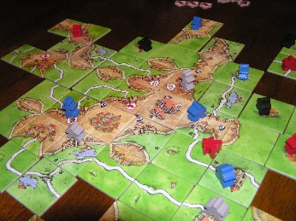
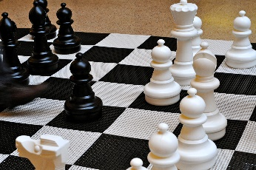
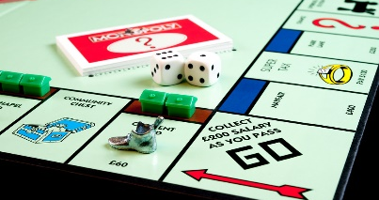
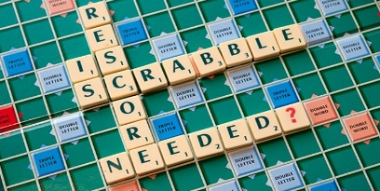
The Games Club are a group of keen and sociable adult board gamers, playing everything from classics such as Monopoly, Scrabble, Chess & Articulate to the more modern “gateway” Euro strategy games such as Carcassonne, CodeNames, Pandemic & Ticket to Ride
We meet on the last Wednesday of each month from 7:30 - 10:00pm
in the Village Hall
Our usual format is to play a couple of games each evening with a break for drinks, snacks and a chat in between, new members are always welcome
For further details please contact Mike & Lesley Brazel
on 01832 710824 or email lesleybrazel@hotmail.com.

